
CourseWeb ACCOUNT REGISTRATION FORM

FACULTY DETAILS
DEPARTMENT
FACULTY ID
FULL NAME
QUALIFCATION
DESIGNATION
RESEARCH AREA
DOMAIN MAIL-ID
PERSONAL MAIL-ID
MOBILE NUMBER
APPLICATION DATE
PHOTO | (Send your pass-photo as an email attachment while sending application through email)

*** Domain mail-id is mandatory, Get your domain-mail first ***
Dear faculty,
Please Send filled in application form to courseweb@kitsw.ac.in through your domain mail-id. After your account creation, detailed login instructions will be sent back to your domain-id.
Thank you

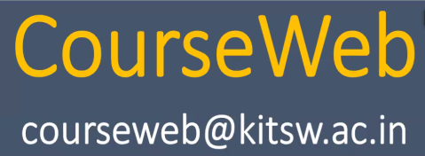
D.Ramesh,
Faculty I/C, CourseWeb.
Assistant Professor, CSE(N)
Mobile: 9491320100

